3-2 Catapult Basket

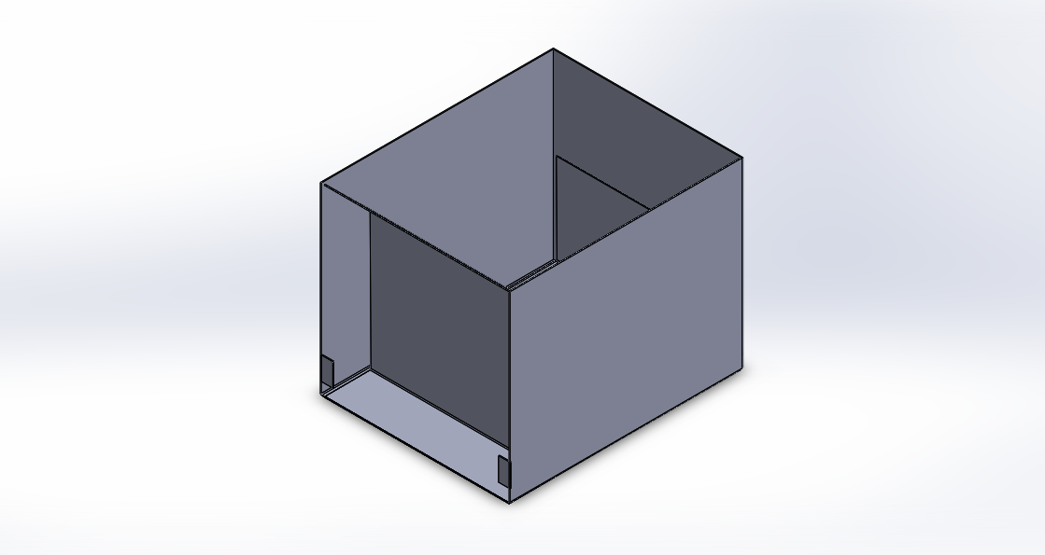

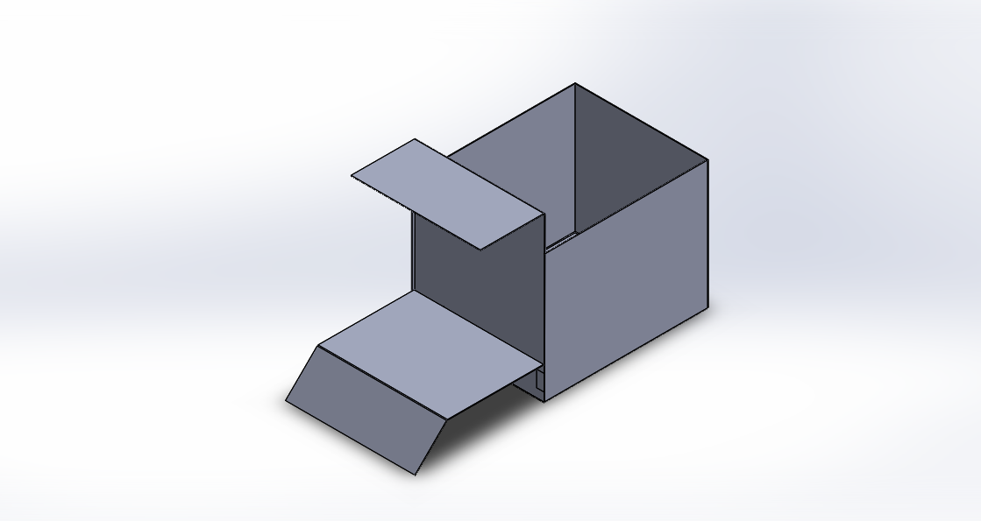

The above figures show isometric views of the robot’s catapult basket in its two different states: unfired and fired. The basket unfired length, width, and height are 8”, 10”, and 8” respectively. The 10” width will travel parallel to the width of the robot, in order to fire the first three pets off the side of the ramp and into the start area. The basket’s maximum length, width, and height after it is fired would be 8”, 18”, and 10” respectively.

The catapult is fired using 2 torsion springs, one on each end of the basket’s length. Using the figure below we may find the minimum spring constant of the torsion spring as a function of the distance needed to travel to reach start area. Please note that the pets were idealized as cylinders of 6” height and 4” diameter during these calculations.

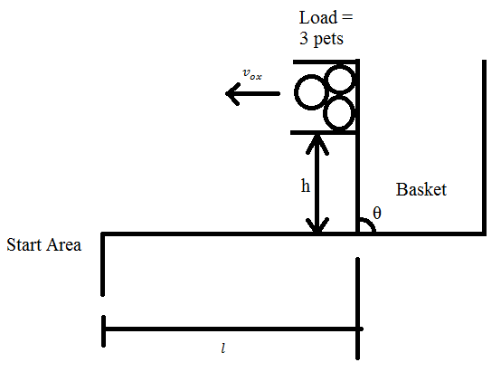

Figure : Projectile motion of the pets

Relevant Equations:

$$t_{flight}=\frac{l}{v_{ox}}$$

$$h=\frac{1}{2}gt_{flight}^{2}=\frac{gl^{2}}{2v_{ox}^{2}}$$

$$v_{ox}=\sqrt{\frac{gl^{2}}{2h}} \text{ at height }h$$

Conservation of Energy shows:

$$U_{spring}=\frac{1}{2}kθ^{2}={KE}_{load}+{PE}_{load}={\frac{1}{2}m}_{load}v_{ox}^{2}+ m_{load}gh$$

Rearranging the terms, and given that $θ=π/2$ when the basket is fired, we find the minimum required spring constant of one torsion spring $k_{min}$ as a function of $h \text{and }l$:

$$k_{min}\left(h,l\right)=\frac{8m_{load}}{π^{2}}\left[\frac{gl^{2}}{4h}+gh\right]$$

The known constants are:

$$g=\text{acceleration due to gravity}≈9.81m/s^{2}$$

$$m_{load}=\text{mass of three pets}≈2.55×{10}^{-2}kg$$

The release mechanism involves a pin attached to a pull solenoid holding the catapult down, and passing through a hole through the basket and the catapult. Once the catapult is required to fire, the solenoid pulls the pin and the torsion springs retract and fires the catapult.

